Pain Is Not A Symptom Of Arthritis, Pain Causes Arthritis, Study Shows
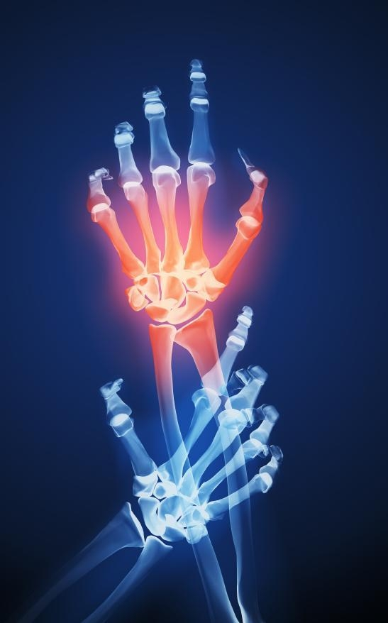
Pain is more than a symptom of osteoarthritis, it is an inherent and damaging part of the disease itself, according to a new study.

Pain is more than a symptom of osteoarthritis, it is an inherent and damaging part of the disease itself, according to a study just published in journal Arthritis and Rheumatism. More specifically, the study revealed that pain signals originating in arthritic joints, and the biochemical processing of those signals as they reach the spinal cord, worsen and expand arthritis.
In addition, researchers found that nerve pathways carrying pain signals transfer inflammation from arthritic joints to the spine and back again, causing disease at both ends.
Technically, pain is a patient's conscious realization of discomfort. Before that can happen, however, information must be carried along nerve cell pathways from say an injured knee to the pain processing centers in dorsal horns of the spinal cord, a process called nociception. The current study provides strong evidence that two-way, nociceptive "crosstalk" may first enable joint arthritis to transmit inflammation into the spinal cord and brain, and then to spread through the central nervous system (CNS) from one joint to another.
Furthermore, if joint arthritis can cause neuro-inflammation, it could have a role in conditions like Alzheimer's disease, dementia and multiple sclerosis. Armed with the results, researchers have identified likely drug targets that could interfere with key inflammatory receptors on sensory nerve cells as a new way to treat osteoarthritis (OA), which destroys joint cartilage in 21 million Americans. The most common form of arthritis, OA eventually brings deformity and severe pain as patients loose the protective cushion between bones in weight-bearing joints like knees and hips.
"Until relatively recently, osteoarthritis was believed to be due solely to wear and tear, and inevitable part of aging," said Stephanos Kyrkanides, D.D.S., Ph.D., associate professor of Dentistry at the University of Rochester Medical Center. "Recent studies have revealed, however, that specific biochemical changes contribute to the disease, changes that might be reversed by precision-designed drugs. Our study provides the first solid proof that some of those changes are related to pain processing, and suggests the mechanisms behind the effect," said Kyrkanides, whose work on genetics in dentistry led to broader applications. The common ground between arthritis and dentistry: the jaw joint is a common site of arthritic pain.
Study Details
Past studies have shown that specific nerve pathways along which pain signals travel repeatedly become more sensitive to pain signals with each use. This may be a part of ancient survival skill (if that hurt once, don't do it again). Secondly, pain has long been associated with inflammation (swelling and fever).
In fact, past research has shown that the same chemicals that cause inflammation also cause the sensation of pain and hyper-sensitivity to pain if injected. Kyrkanides' work centers around one such pro-inflammatory, signaling chemical called Interleukin 1-beta (IL-1β), which helps to ramp up the bodies attack on an infection.
Specifically, Kyrkanides' team genetically engineered a mouse where they could turn up on command the production of IL-1β in the jaw joint, a common site of arthritis. Experiments showed for the first time that turning up IL-1β in a peripheral joint caused higher levels of IL-1β to be produced in the dorsal horns of the spinal cord as well.
Using a second, even more elaborately engineered mouse model, the team also demonstrated for the first time that creating higher levels of IL-1β in cells called astrocytes in the spinal cord caused more osteoarthritic symptoms in joints. Past studies had shown astrocytes, non-nerve cells (glia) in the central nervous system that provide support for the spinal cord and brain, also serve as the immune cells of CNS organs. Among other things, they release cytokines like IL-1β to fight disease when triggered. The same cytokines released from CNS glia may also be released from neurons in joints, possibly explaining how crosstalk carries pain, inflammation and hyper-sensitivity back and forth.
In both mouse models, experimental techniques that shut down IL-1β signaling reversed the crosstalk effects. Specifically, researchers used a molecule, IL-1RA, known to inhibit the ability of IL-1β to link up with its receptors on nerve cells. Existing drugs (e.g. Kineret® (anakinra), made by Amgen and indicated for rheumatoid arthritis) act like IL-1RA to block the ability IL-1β to send a pain signal through its specific nerve cell receptor, and Kyrkanides' group is exploring a new use for them as osteoarthritis treatment.
The implications of this process go further, however, because the cells surrounding sensory nerve cell pathways too can be affected by crosstalk. If 10 astrocytes secrete IL-1β in response to a pain impulse, Kyrkanides said, perhaps 1,000 adjacent cells will be affected, greatly expanding the field of inflammation. Spinal cord astrocytes are surrounded by sensory nerve cells that connect to other areas of the periphery, further expanding the effect. According to Kyrkanides' model, increased inflammation by in the central nervous system can then send signals back down the nerve pathways to the joints, causing the release of inflammatory factors there.
Among the proposed, inflammatory factors is calcitonin gene related peptide (CGRP). The team observed higher levels calcitonin-gene related peptide (CGRP) production in primary sensory fibers in the same regions where IL-1β levels rose, and the release of IL-1β by sensory neurons may cause the release of CGRP in joints. Past studies in Kyrkanides reveal that CGRP can also cause cartilage-producing cells (chondrocytes) to mature too quickly and die, a hallmark of osteoarthritis.
Joining Kyrkanides in the publication from the University of Rochester School of Medicine and Dentistry were co-authors M. Kerry O'Banion, M.D., Ph.D., Ross Tallents, D.D.S., J. Edward Puzas, Ph.D. and Sabine M. Brouxhon, M.D. Paolo Fiorentino was a student contributor and Jennie Miller was involved as Kyrkanides' technical associate. Maria Piancino, led a collaborative effort at the University of Torino, Italy. This work was supported in part by grants from the National Institutes of Health.
"Our study results confirm that joints can export inflammation in the form of higher IL-1β along sensory nerve pathways to the spinal cord, and that higher IL-1β inflammation in the spinal cord is sufficient in itself to create osteoarthritis in peripheral joints," Kyrkanides said. "We believe this to be a vitally important process contributing to orthopaedic and neurological diseases in which inflammation is a factor."

